HARROGATE MALE VOICE CHOIR
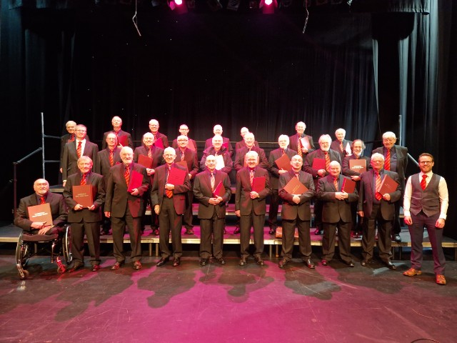
Director: Richard Kay
‘THE MONTH BEFORE CHRISTMAS’
GREEN HAMMERTON VILLAGE HALL
SATURDAY, 25th. NOVEMBER 2023
7.30 P.M. (Doors Open 7.00 P.M.)
Mulled wine, Mince pies, Christmas cake, Xmas decorations
TICKETS: £10.00
Available from Green Hammerton Library
Library Cottage, YO26 8AE
Email: contact@greenhammertonlibrary.co.uk
Tel: 01423 368886 / 07984 972 495
Proceeds in aid of Green Hammerton Library
www.greenhammertonlibrary.co.uk

