HARROGATE MALE VOICE CHOIR
PRESENT
THEIR ANNUAL ‘SING OUT’ CONCERT
FEATURING WESTERN PRIMARY SCHOOL’S CHOIR
WHEN? SATURDAY, 13TH MAY 2023
WHERE? HARROGATE GRAMMAR SCHOOL
OTLEY ROAD HG2 0NA
TIME? 7.00 P.M.
TICKETS: £10.00 (CHILDREN 16 & under FREE)
PLEASE RING Lawrie Coulthard on 07905515492 or Ian Brocket on 07837776406
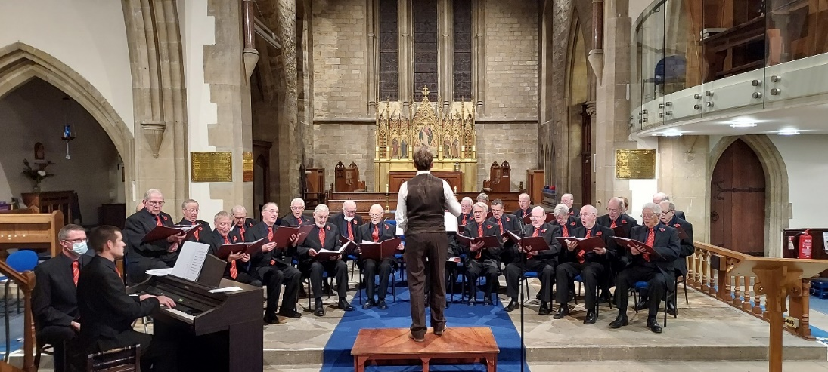
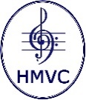
Registered Charity No. 1131035 www.Harrogatemvc.co.uk
HMVC to make a donation to Harrogate Friends of Ukraine/Harrogate District of Sanctuary

